**Sample Title:** Dynamical Systems Modeling of Six Database-Derived Gene Regulatory Networks and Associated Random Networks Identifies Key Regulators Controlling the Response to Cold Shock in *Saccharomyces cerevisiae*

**References:**

Aguilera, J., Randez-Gil, F., and Prieto, J.A. (2007). Cold response in *Saccharomyces cerevisiae*:

new functions for old mechanisms. *FEMS Microbiology Reviews*, *31*(3), 327-341. DOI: 10.1111/j.1574-6976.2007.00066.x.

Review article discussing the molecular mechanisms underlying the detection of cold, signal transduction, and cellular response in *S. cerevisiae*. Of note is a section entitled “Cold-sensitive mutants and the cold ribosome adaptation hypothesis”, which references deletion strains showing slow growth phenotypes at cold temperatures (see Hampsey, 1997) and the notion that *de novo* synthesis of cold-tolerant ribosomes is a key part of the initial response to cold shock. One line of support for this hypothesis includes the observation that nearly one-third of genes up-regulated in *S. cerevisiae* during cold shock encode ribosomal proteins (see Sahara et al., 2002). The article further articulates the need for study of the transcription factors controlling this cellular response to cold shock.

Al-Fageeh, M.B., and Smales, C.M. (2006). Control and regulation of the cellular responses to cold

shock: the responses in yeast and mammalian systems. *Biochemical Journal*, *397*(2), 247-

259. DOI: 10.1042/BJ20060166.

Review article discussing the molecular responses to cold shock in *S. cerevisiae*, as well as in *E. coli* and mammalian systems. Details gene expression changes derived from several microarray studies that characterize the cold-shock response and near-freezing response (see Kandror et al. 2004) in yeast. Of particular interest are discussions of the following points: mRNA and ribosome instability during cold shock, the need for upregulated ribosome biogenesis to compensate for impaired translation during cold shock, microarray noise resulting from impaired translation during cold shock (see Rodriguez-Vargas et al. 2002), and the role of MSN4 in upregulating stress response elements (see Kandror et al. 2004)

Becskei, A., and Serrano, L. (2000). Engineering stability in gene networks by autoregulation.

*Nature*, *405*(6786), 590-593. DOI: 10.1038/35014651.

Primary article. In this integrative theoretical-experimental study, the authors provide evidence that autoregulatory negative feedback loops in gene regulatory networks provide stability in the face of environmental perturbation. This article may be useful in the interpretation of motifs identified in our database-derived networks, or aid in the comparison of database-derived networks versus random networks.

Berger, A.B., Decourty, L., Badis, G., Nehrbass, U., Jacquier, A., and Gadal, O. (2007). Hmo1 is

Required for TOR-Dependent Regulation of Ribosomal Protein Gene Transcription. *Molecular and Cellular Biology*, *27*(22), 8015-8026. DOI: 10.1128/MCB.01102-07.

Primary article. The authors applied genetic-interaction-with-gene-deletion (GID) screens to elucidate interactions between Hmo1 and other transcription factors and pathways in *S. cerevisiae.* Results of these screens demonstrated that transcription factors interacting with Hmo1 were associated with three key cellular functions: transcription, ribosome biogenesis, and various stress response pathways. Sample growth experiment results, including those double deletion mutants that resulted in synthetic lethality, are shown in Figure 1 below. Further experimentation suggested that TORC1-dependent regulation of ribosomal proteins (both up-regulation and down-regulation) was dependent on Hmo1.

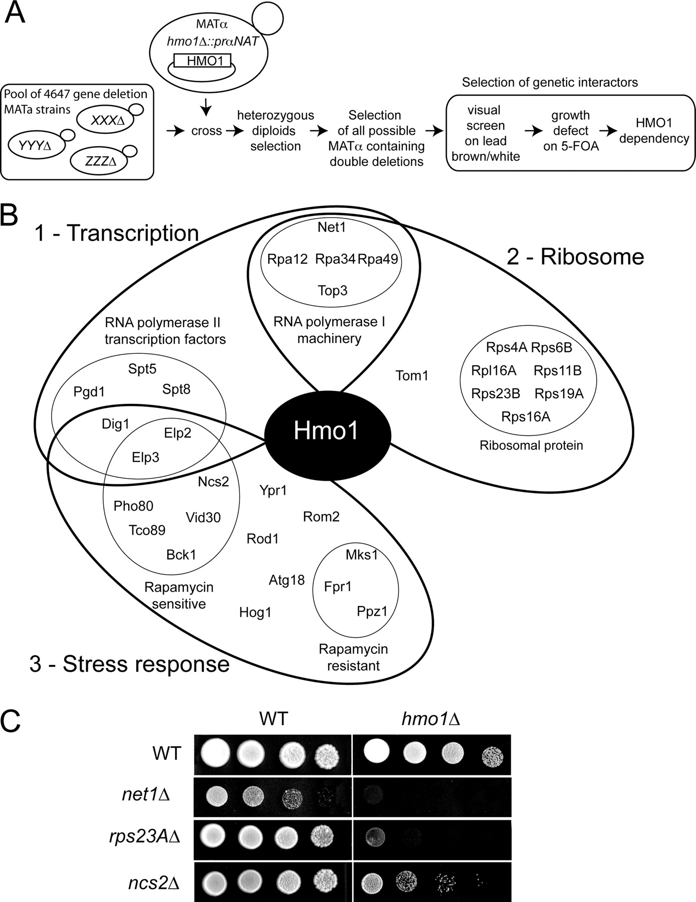

**Figure 1**

Cherry, J.M., Hong, E.L., Amundsen, C., Balakrishnan, R., Binkley, G., Chan, E.T., ... and Fisk, D.G. (2011). Saccharomyces Genome Database: the genomics resource of budding yeast. *Nucleic Acids Research*, *40*(D1), D700-D705. DOI:10.1093/nar/gkr1029.

Primary article. The authors introduce Saccharomyces Genome Database (SGD), a model organism database for *S. cerevisiae* (<https://www.yeastgenome.org/>). In doing so, they provide a substantive discussion regarding why *S. cerevisiae* has been adopted as a model organism for the systems biology community, and how the study of *S. cerevisiae* has advanced the genomics research. This reference may prove useful either to justify the use of *S. cerevisiae* as a model organism or to cite if referencing information from SGD.

Dahlquist, K.D., Dionisio, J.D.N., Fitzpatrick, B.G., Anguiano, N.A., Varshneya, A., Southwick, B.J.,

and Samdarshi, M. (2016). GRNsight: a web application and service for visualizing models of small-to medium-scale gene regulatory networks. *PeerJ Computer Science*, *2*, e85. DOI: 10.7717/peerj-cs.85.

Primary article published by the Dahlquist Lab. This article details the use of the GRNsight for the visualization of gene regulatory networks, using examples produced our lab. It will be useful to refer back to this article and cite it when mentioning the use of GRNsight.

Dahlquist, K.D., Fitzpatrick, B.G., Camacho, E.T., Entzminger, S.D., and Wanner, N.C. (2015).

Parameter Estimation for Gene Regulatory Networks from Microarray Data: Cold Shock Response in *Saccharomyces cerevisiae*. *Bulletin of Mathematical Biology*, *77*(8), 1457-1492. DOI: 10.1007/s11538-015-0092-6.

Primary article published by the Dahlquist Lab. This article details the use of the GRNmap software for modeling and parameter estimation for gene regulatory networks in *S. cerevisiae*. Specifically, a 21 gene, 31 edge GRN controlling the transcriptional response to cold shock in yeast was investigated. This article will be a useful reference material and can be cited when referring back to published lab methodology.

Gasch, A.P., Spellman, P.T., Kao, C.M., Carmel-Harel, O., Eisen, M.B., Storz, G., ... and Brown, P.O.

(2000). Genomic Expression Programs in the Response of Yeast Cells to Environmental Changes. *Molecular Biology of the Cell*, *11*(12), 4241-4257. DOI: 10.1091/mbc.11.12.4241.

Primary article. Microarray experiments were performed in which wild-type *S. cerevisiae* was exposed to varying, diverse environmental stresses. The authors report ~900 genes that showed similar transcriptional responses to nearly all stressors, termed the environmental stress response (ESR). Subsequent testing of deletion strains suggested that the ESR is dependent on the transcription factors YAP1, MSN2, and MSN4.

Hampsey, M. (1997). A Review of Phenotypes in *Saccharomyces cerevisiae*. *Yeast*, *13*(12), 1099-

1133. DOI: 10.1002/(SICI)1097-0061(19970930)13:12<1099::AID-YEA177>3.0.CO;2-7.

Review article compiling known mutant phenotypes of *Saccharomyces cerevisiae.* The cold sensitivity phenotype is discussed on pg. 1104, and it is mentioned that this phenotype has been studied to identify genes important to ribosome assembly / biogenesis.

Hansen, P.C., and O’Leary, D.P. (1993). The Use of the L-Curve in the Regularization of Discrete Ill-

Posed Problems. *SIAM Journal on Scientific Computing*, *14*(6), 1487-1503. DOI: 10.1137/0914086.

Primary article. The authors describe the L-curve, which plots the size of a regularized solution against the size of the associated residual. They propose that L-curve plots can be used to assess the efficiency of regularization methods when attempting to solve (“ill-posed”) problems with many possible solutions. Further, the authors propose the use of L-curve plots for selecting efficient regularization parameters—an approach that we have adopted in GRNmap. Given my work creating the L-curve R script and generating L-curves, this reference may be helpful in providing methodological context.

Kandror, O., Bretschneider, N., Kreydin, E., Cavalieri, D., and Goldberg, A.L. (2004). Yeast Adapt to

Near-Freezing Temperatures by STRE/Msn2, 4-Dependent Induction of Trehalose Synthesis and Certain Molecular Chaperones. *Molecular Cell*, *13*(6), 771-781. DOI: 10.1016/S1097-2765(04)00148-0.

Primary article. Microarray experiments were performed to assess the transcriptional response to temperatures between 0-10°C in *S. cerevisiae*. The near-freezing response was characterized, involving elements of the ESR (e.g. heat shock proteins), trehalose synthesis, and induction of molecular chaperones. The near-freezing response was shown to be Msn2p/Msn4p dependent upon characterization of mutant strains.

Lee, T.I., Rinaldi, N.J., Robert, F., Odom, D.T., Bar-Joseph, Z., Gerber, G.K., ... and Zeitlinger, J.

(2002). Transcriptional regulatory networks in *Saccharomyces cerevisiae*. *Science*, *298*(5594), 799-804. DOI: 10.1126/science.1075090.

Primary article. A genome-wide location analysis experiment was performed for all 141 transcription factors in *S. cerevisiae* with known DNA binding to determine relationships between TFs and the genes they regulate. Motifs were taken to represent the building blocks of regulatory networks and identified using a Matlab algorithm (<http://younglab.wi.mit.edu/cgi-bin/young_public/navframe.cgi?s=17&f=network-analysis)>. Six different motifs were identified (Fig. 3 below): autoregulation, multicomponent loops, feedforward loops, single-input, multi-input, and regulator chain. Of these, we have discussed autoregulation (HMO1), feedforward loops (db7), and regulator chains (SCSBC 2017). The authors note that autoregulation is thought to hasten response time to inputs (see Becskei and Serrano, 2000) and that regulator chains represent temporal circuits (see Simon et al. 2001). These motifs were then used to construct GRNs controlling global transcriptional responses in yeast (Fig. 5 below).

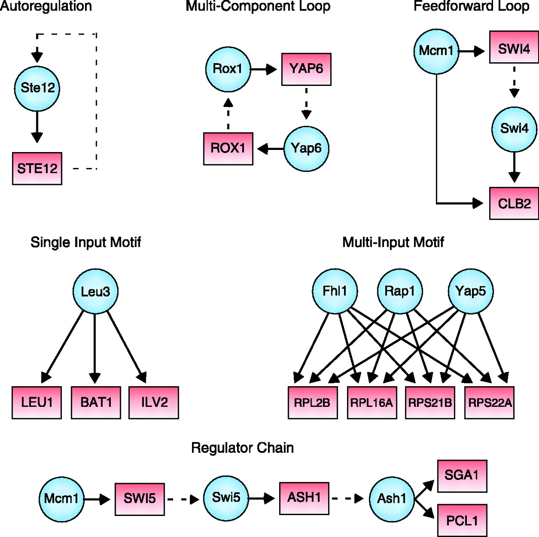 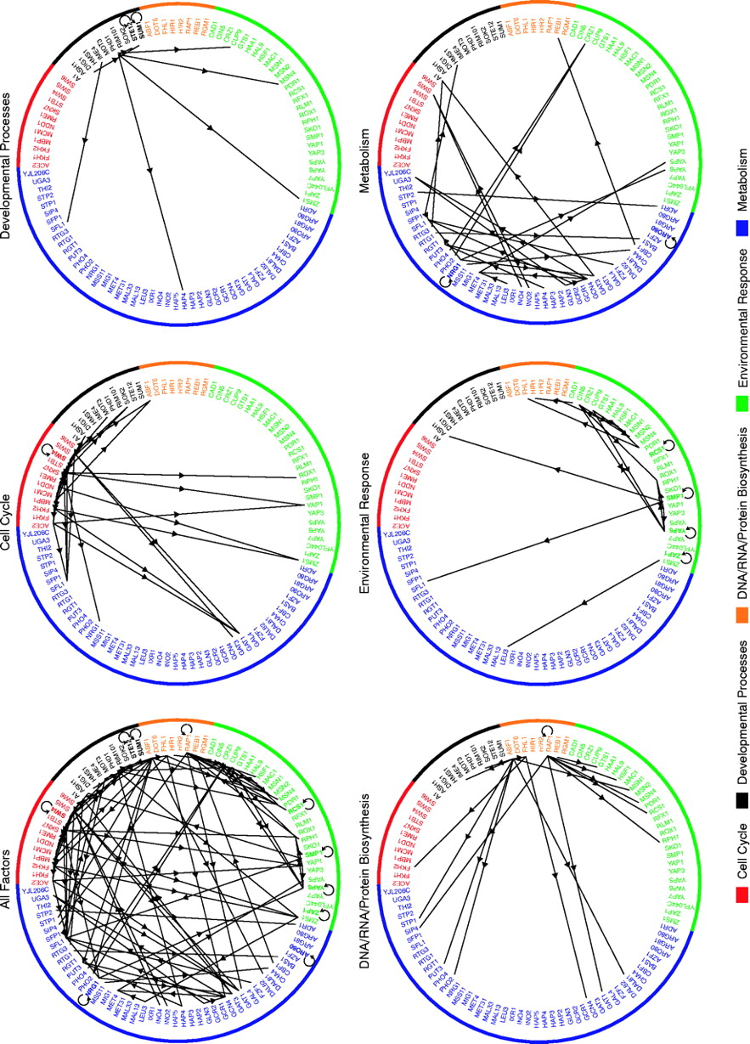

**Figure 3 Figure 5**

Neymotin, B., Athanasiadou, R., and Gresham, D. (2014). Determination of in vivo RNA kinetics

using RATE-seq. *RNA*, *20*(10), 1645-1652. DOI: 10.1261/rna.045104.114.

Primary article. The authors estimated genome-wide kinetic parameters for RNA transcripts in *S. cerevisiae* using RNA-seq. We derived the degradation rates input into GRNmap for all 6 database-derived networks and associated random networks from the half-lives reported in this paper. Thus, a citation will be necessary in the materials and methods section of the thesis.

Panday, A. and Grove, A. (2016). The high mobility group protein HMO1 functions as a linker histone in yeast. *Epigenetics & Chromatin*, *9*(1), 13. DOI: 10.1186/s13072-016-0062-8.

Primary article mentioned in the following issue: <https://github.com/kdahlquist/GRNmap/issues/374>. The authors investigated wild type and deletion strains of *S. cerevisiae* to characterize the molecular mechanisms of HMO1. They argue that HMO1 functions as a linker histone analogous to the human histone H1 and is necessary for chromatin compaction. The authors go on to speculate that upregulated chromatic compaction may aid the ability of *S. cerevisiae* to withstand environmental stress. Given the prominent role of HMO1 in our database-derived gene regulatory networks, this additional molecular mechanism of HMO1 may be useful to reference when interpreting our GRNs.

Rodriguez-Vargas, S., Estruch, F., and Randez-Gil, F. (2002). Gene Expression Analysis of Cold

and Freeze Stress in Baker's Yeast. *Applied and Environmental Microbiology*, *68*(6), 3024-3030. DOI: 10.1128/AEM.68.6.3024–3030.2002.

Primary article. The mRNA differential display technique was used to assess the transcriptional response to cold shock in *S. cerevisiae*. The authors report that most genes that exhibited significant expression changes were repressed, which they speculate is due to impaired translation at low temperatures. This reflects both the role of noise in interpreting data regarding transcriptional changes during cold shock as well as the potential importance of *de novo* ribosome biogenesis in the early response to cold shock in *S. cerevisiae*.

Sahara, T., Goda, T., and Ohgiya, S. (2002). Comprehensive Expression Analysis of Time-

dependent Genetic Responses in Yeast Cells to Low Temperature. *Journal of Biological Chemistry*, *277*(51), 50015-50021. DOI: 10.1074/jbc.M209258200.

Primary Article. The global transcriptional response to cold shock in *S. cerevisiae* was investigated via microarray experiments. The authors report transcriptional changes in approximately 25% of the genome that could be broken up into three distinct temporal phases (early, middle, and late). Large clusters of up-regulated genes were known to be involved in rRNA synthesis, ribosome protein synthesis (collectively, ribosome biogenesis), and the environmental stress response. The authors speculate that early up-regulation of ribosome biogenesis allows for improved translational efficiency at low temperatures.

Schade, B., Jansen, G., Whiteway, M., Entian, K.D., and Thomas, D.Y. (2004). Cold Adaptation in

Budding Yeast. *Molecular Biology of the Cell*, *15*(12), 5492-5502. DOI: 10.1091/mbc.E04–03–0167.

Primary article. The response to cold shock in *S. cerevisiae* was probed through microarray experiments using both a wild-type strain and ∆*msn2* ∆*msn4* double deletion strain. The authors characterize an early cold response (ECR; 2 hours) and late cold response (LCR; 12 hours). The LCR exhibits substantial overlap with the environmental stress response (ESR; see Gasch et al. 2000) and is Msn2p/Msn4p dependent. Interestingly, the authors report that the ECR is Msn2p/Msn4p independent, with no significant transcriptional difference observed in the ECR between WT and ∆*msn2* ∆*msn4* strains. Also of note, our lab has previously modeled GRNs using microarray data from Schade et al.

Simon, I., Barnett, J., Hannett, N., Harbison, C.T., Rinaldi, N.J., Volkert, T.L., ... and Young, R.A.

(2001). Serial Regulation of Transcriptional Regulators in the Yeast Cell Cycle. *Cell*, *106*(6), 697-708. DOI: 10.1016/S0092-8674(01)00494-9.

Primary article. Genome-wide location analysis experiments were performed to determine the transcriptional targets of nine regulators implicated in control of the cell cycle. The authors determined which regulators, including four appearing in our database-derived networks (Ace2, Mcm1, Swi4, Swi5), were responsible for the expression of genes associated with particular temporal components of the cell cycle (Figure 2). Further, the authors go on to demonstrate that these transcriptional activators form a GRN. In this GRN, a regulator chain is present that appears to temporally regulate cell cycle transitions.

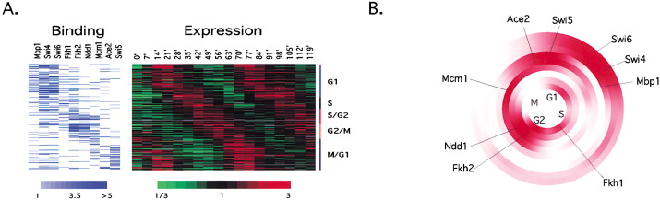

**Figure 2**

(Aside: combine fig. 2 w/ dB3 🡪 MCM1 upregulating G1 TFs (ACE2, SWI4/5) 🡪 stabilize in G1 / no division?)

Teixeira, M.C., Monteiro, P.T., Palma, M., Costa, C., Godinho, C.P., Pais, P., ... and Sá-Correia, I.

(2017). YEASTRACT: an upgraded database for the analysis of transcription regulatory networks in Saccharomyces cerevisiae. *Nucleic Acids Research*, *46*(D1), D348-D353. DOI: 10.1093/nar/gkx842.

Primary article. The authors describe the YEAst Search for Transcriptional Regulators And Consensus Tracking (YEASTRACT) information system as well as updates made to it. YEASTRACT supports the identification and analysis of gene regulatory relationships in *S. cerevisiae*. In our data analysis workflow, lists of transcription factors regulating genes that exhibited significant log2 fold changes in our microarray experiments were output from YEASTRACT when creating database-derived networks. Thus, a citation will be necessary in the materials and methods section of the thesis.

Xiao, L., and Grove, A. (2009). Coordination of Ribosomal Protein and Ribosomal RNA Gene

Expression in Response to TOR Signaling. *Current Genomics*, *10*(3), 198-205. DOI: 10.2174/138920209788185261.

This review article provides an in-depth discussion of TOR signaling in *S. cerevisiae*. TOR signaling is involved in the stress response, regulates ribosome biogenesis as well as translation initiation, and is dependent on HMO1. This article can be used in combination with Berger et al. 2007 to draw links between HMO1 regulation, TOR signaling, and ribosome biogenesis in response to cold shock.

Youn, J. Y., Friesen, H., Ba, A. N. N., Liang, W., Messier, V., Cox, M. J., ... and Andrews, B. (2017). Functional Analysis of Kinases and Transcription Factors in *Saccharomyces cerevisiae* Using an Integrated Overexpression Library. *G3: Genes, Genomes, Genetics*, *7*(3), 911-921. DOI: 10.1534/g3.116.038471.

Primary article. The phenotypes of various strains of *S. cerevisiae* mutated to exhibit transcription factor and kinase overexpression were systematically analyzed to determine genetic interactions. In these experiments, synthetic lethality (SL) resulted from reduced Cdc28 abundance in combination with deletion of either STB1 or YHP1. The authors provide evidence suggesting that phosphorylation by the kinase Cdc28 is necessary for the degradation of STB1 and YHP1 and successful completion of the cell cycle. Without such degradation, STB1 and YHP1 overexpression arrests the cell cycle at the M/G1 interval, resulting in SL. These findings provide insights regarding the functions of STB1 and YHP1 in *S. cerevisiae*.

**Articles for Further Review:** (citations not formatted properly)

* Kawakami, E., Singh, V. K., Matsubara, K., Ishii, T., Matsuoka, Y., Hase, T., ... & Subramanian, I. (2016). Network analyses based on comprehensive molecular interaction maps reveal robust control structures in yeast stress response pathways. *npj Systems Biology and Applications*, *2*, 15018.
* Costanzo, M., VanderSluis, B., Koch, E. N., Baryshnikova, A., Pons, C., Tan, G., ... & Pelechano, V. (2016). A global genetic interaction network maps a wiring diagram of cellular function. *Science*, *353*(6306), aaf1420.
  + [**http://thecellmap.org/**](http://thecellmap.org/)
* Thattai, M., & Van Oudenaarden, A. (2001). Intrinsic noise in gene regulatory networks. *Proceedings of the National Academy of Sciences*, *98*(15), 8614-8619.
* Song, L., Huang, S. S. C., Wise, A., Castanon, R., Nery, J. R., Chen, H., ... & Ecker, J. R. (2016). A transcription factor hierarchy defines an environmental stress response network. *Science*, *354*(6312), aag1550.
* Shannon, P., Markiel, A., Ozier, O., Baliga, N. S., Wang, J. T., Ramage, D., ... & Ideker, T. (2003). Cytoscape: a software environment for integrated models of biomolecular interaction networks. *Genome research*, *13*(11), 2498-2504.
* Karlebach, G., & Shamir, R. (2008). Modelling and analysis of gene regulatory networks. *Nature Reviews Molecular Cell Biology*, *9*(10), 770-780.
* Segal, E., Shapira, M., Regev, A., Pe'er, D., Botstein, D., Koller, D., & Friedman, N. (2003). Module networks: identifying regulatory modules and their condition-specific regulators from gene expression data. *Nature genetics*, *34*(2), 166-176.